Operational Concept Description (OCD)

PicShare

Team 02

Team Members
Sultan Alsarra
Adil cem Albayrak
Julapat Julnual
Charles Reitz
Mohammad Almunea
Aref Shafaeibejestan
Andrea Brown
Travis Weaver

12/07/15

Version History
Date | Author | Version | Changes made | Rationale
10/18/15 | Mohammad & Aref | 0.9 | - Introduction, Shared Vision and System Transformation added. | - OCD draft before presentation.
10/25/15 | Mohammad & Aref | 1.0 | - Fix some issues in the Benefit Chain Diagram  - Fix minor issue with the System Boundaries Diagram  - Introduce a new priority level in the Capability Goals section. | - First Version FCP
11/29/15 | Mohammad & Aref | 2.0 | - Changed Some Capability Goals  - Changed Some Constraints | - DCR Package
12/4/15 | Mohammad & Aref | 2.1 | - Add initiatives to the Benefit Chain Diagram | - DCR Package

Table of Contents
Operational Concept Description (OCD) i
Version History ii
Table of Contents iii
Table of Tables iv
Table of Figures v
1. Introduction 1
1.1 Purpose of the OCD 1
1.2 Status of the OCD 1
2. Shared Vision 2
2.1 Benefits Chain 3
2.2 System Capability Description 3
2.3 System Boundary and Environment 4
3. System Transformation 5
3.1 Information on Current System 5
3.2 System Objectives, Constraints and Priorities 7
3.3 Proposed New Operational Concept 9
3.4 Organizational and Operational Implications 13

Table of Tables
Table 1: The Program Model 2
Table 3: Relation to Current System 8

Table of Figures
Figure 1: Benefits Chain Diagram 3
Figure 2: System Boundary and Environment Diagram 4
Figure 3: Current Business Workflow 6
Figure 4: Element Relationship Diagram 9
Figure 5: Business Workflow: Create Event 10
Figure 6: Business Workflow: Share Picture to Event 11
Figure 7: Business Workflow: Share Picture to Nearby Location 12

Introduction

Purpose of the OCD
The purpose of this OCD document is to give an in-depth detail of the shared visions and goals of the stakeholders for the PicShare mobile application. The success-critical stakeholders for the project are Rigo Garcia as the project owner. The users who are going to be USC students in the initial phase of the project. Team 2 as the developers of the system.

Status of the OCD
The status of the OCD is currently under development version number 1.0. All the OCD main sections have been completed according to the Foundation Commitment Package requirements.

Shared Vision
Our vision, in this project, is to create a mobile application that makes picture sharing easier than it is today.

Table 1: The Program Model
Assumptions
- People are willing to share their pictures.
- People have smartphones with camera and Internet connection.
Stakeholders | Initiatives | Value Propositions | Beneficiaries
- Maintainers and Administrators  - Developers  - Users  - Owner | - Design & Develop the new system  - Marketing campaign  - Proper Training and knowledge transfer  - Maintain the System  - Survey and User Testing | - Increase efficiency of sharing pictures.  - Improve user experience by allowing users to create/post different types of events (public, private, location)  - Easier picture sharing options | - Users  - Owner
Legend:
Initiatives that need to be undertaken to help beneficiaries derive value from the expected benefits/value propositions
Initiatives that need to be undertaken to help deliver value to the beneficiaries (i.e. “how” will the benefits reach the beneficiaries?)

Benefits Chain
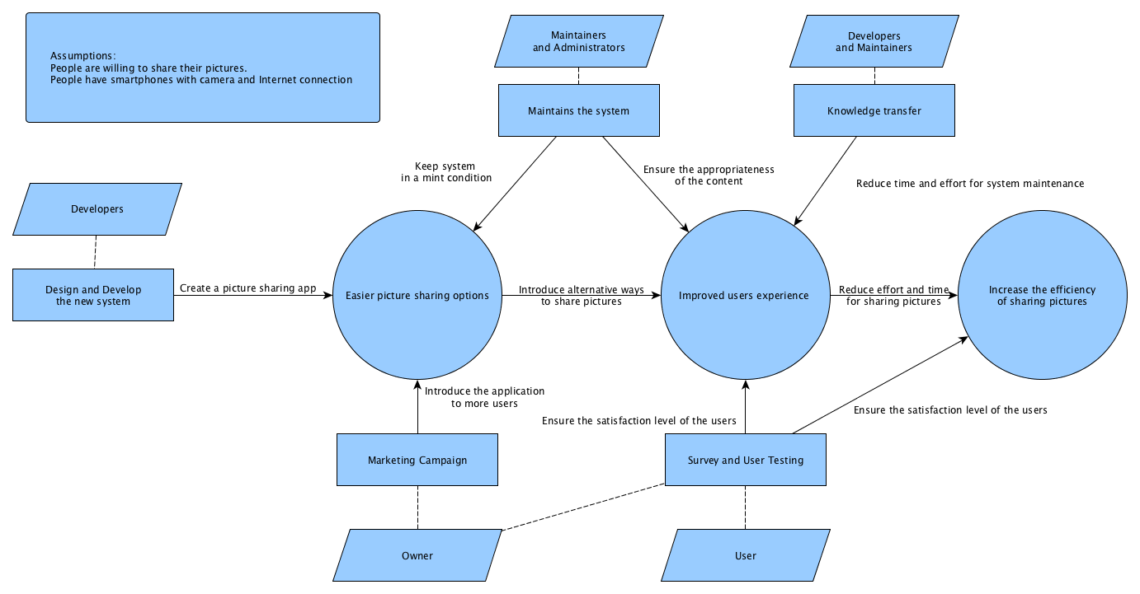
Figure 1: Benefits Chain Diagram

System Capability Description

The mobile app required to be built, aims to make sharing pictures easier for people. The application mainly targets people on the age range of 18-45. in the early phases of deployment, the application will target USC students. PicShare will be capable of taking pictures and give the user two sharing options. The first option is to share the picture based on the location. The second option is to share the picture through public/private hashtags. The second option will give the user the ability to search for public/private hashtags and look to the pictures related to the searched event.

There are many picture sharing competitors in the market like Snapchat and Instagram. However, PicShare has its own unique features like saving pictures which is not available on both Snapchat and Instagram. In addition, the location based picture sharing is a unique feature that is not available in any other application except Snapchat, however Snapchat location based sharing is chose by the Snapchat team, whereas PicShare gives the user the freedom to share pictures based on his location.

System Boundary and Environment
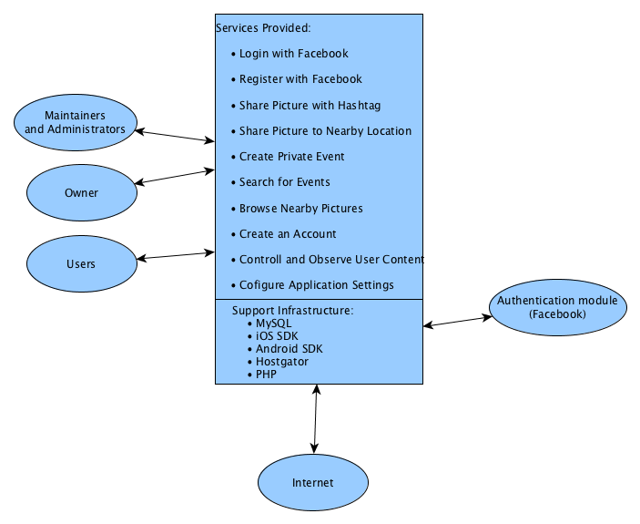
Figure 2: System Boundary and Environment Diagram

System Transformation

Information on Current System

Infrastructure
This is a new application that will be developed from scratch. There is no current infrastructure for this project. The application will be developed for iOS as well as Android. Therefore, Snapchat’s workflow will be used as the current system workflow.

Artifacts
There is no current system for our project. Therefore, we chose Snapchat’s live story as our model.

Artifact | Description
Use Case Diagrams | Describe the required features of the system
Robustness Diagrams | Detailed use cases and how they interact with the system classes.
Activity Diagrams | Defines the flow of a certain process
Design Document | The software description that is given to the development team.
Software Architecture | The structure of a software system.
Prototype | Created to avoid any system risks and defects
Data Model | The relationship between entities.

Current Business Workflow

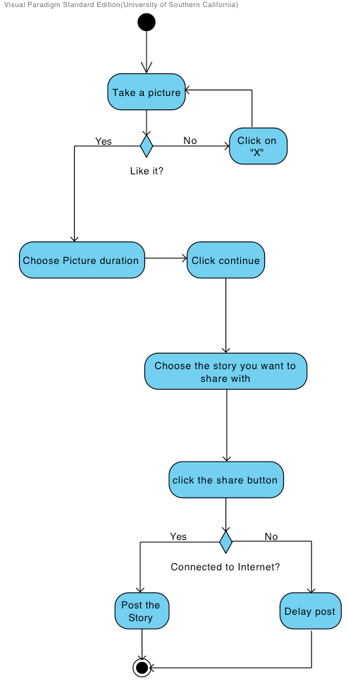
Figure 3: Current Business Workflow

System Objectives, Constraints and Priorities

Capability Goals
Capability Goals | Priority Level
OC-1 Use Hashtag: User can post pictures with a hashtag that indicates a public event | Must Have
OC-2 Login with Facebook: User can login using Facebook. | Must Have
OC-3 Use Location: User can post pictures to the nearby location | Must Have
OC-4 Search Events: User can search events by their name (hashtag). | Must Have
OC-5 Browse Event’s Pictures: User can browse pictures associated with an event and sort them by like or date. | Must Have
OC-6 Administrator: Admin can control and supervise user’s content. | Must Have
OC-7 Delete Picture: Users can delete pictures that they posted. Users can also delete pictures of their private events. | Should Have
OC-8 Create/Delete Private Event: User can create/delete a private event that only people with password has access to it. | Should Have
OC-9 Like/unlike Picture: Users are able to like/unlike a picture | Could Have
OC-10 Report Picture: Users are able to report inappropriate pictures. | Could Have
OC-11 Choose Add Picture Type: When user create a private event they can choose if users can upload pictures, or only post pictures captured live. | Could Have
OC-12 Take Picture or Choose from Gallery: Users can decide whether to take a photo or choose it from gallery when adding a picture. | Could Have
OC-13 Save Picture to Device: User can save the picture to his/her own device. | Could Have

Level of Service Goals
To this point, we haven’t decided about any acceptable goals for the proposed new system's important levels of service.

Organizational Goals
Organizational goals are as follows:

OG-1: Simplify sharing pictures from smart phones.
OG-2: Share location based pictures.
OG-3: Share public and private hashtags with friends and families.
OG-4: Increase efficiency of sharing pictures.
OG-5: Improve user experience by allowing users to create/post different types of events (public, private, location)

Constraints
Constraints are as follows:

CO-1: iOS as an Operating Systems: The new system should be an iOS application.
CO-2: Facebook Login: The user should be able to use the application using his Facebook credentials.
CO-3: Zero Monetary Cost: The Chosen NDI/NCS must be free.
CO-4: Linux as an Operating System: the available server is running Linux.
CO-5: Free Database Systems.

Relation to Current System
In information on current system, we mentioned that since we are building the system from scratch we studied Snapchat’s workflow as current system.
Table 2: Relation to Current System
Capabilities | Current System | New System
Roles and Responsibilities | - User Has access to friends and public events  - User can add picture to his/her story that only friends can see.  - User can add picture to public stories | - User has access to public events and private events that he has their password.  - User can create public events and add/or picture to them.  - User can add picture to private events with password.
User Interactions | - Cannot create story  - Cannot sort pictures that are being shown in story  - Cannot like a picture  - Doesn’t have private story for multiple users | - Create public event by just adding a hashtag to picture  - Sort pictures in a event based on number of likes or time  - Like a picture  - Create private events that everyone with password can access to.
Infrastructure | N/A | New mobile application, server and database.
Stakeholder Essentials and Amenities | N/A | - Easier way of sharing pictures
Future Capabilities | N/A | N/A

Proposed New Operational Concept

Element Relationship Diagram
Figure 4: Element Relationship Diagram
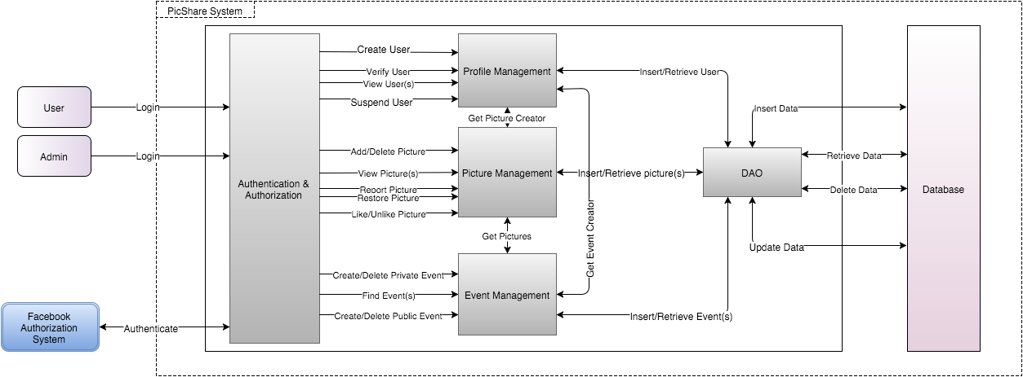

Business Workflows
Since we have a lot of workflows for user, we picked three major ones, which are as follows:

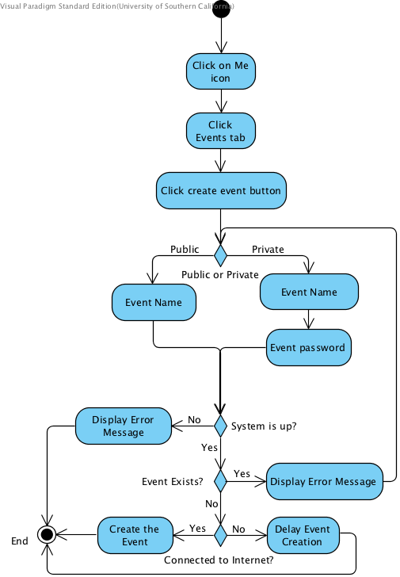
Figure 5: Business Workflow: Create Event

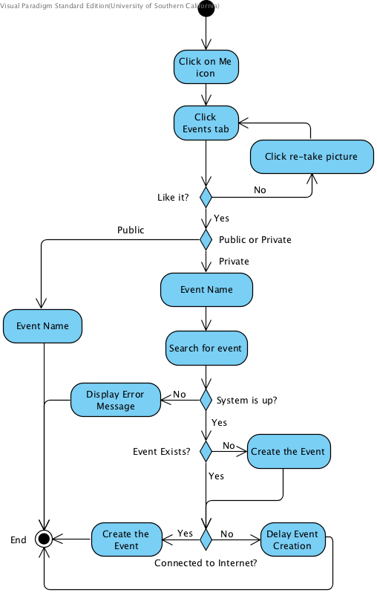
Figure 6: Business Workflow: Share Picture to Event

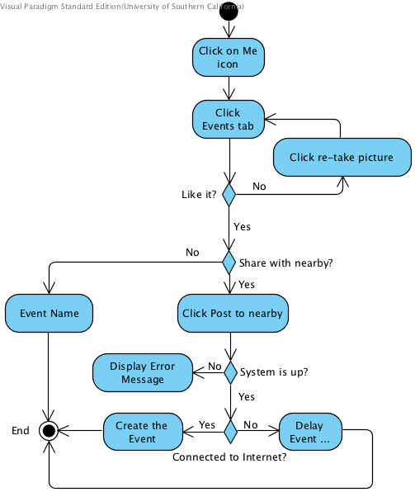
Figure 7: Business Workflow: Share Picture to Nearby Location

Organizational and Operational Implications

Organizational Transformations
- The need to hire new developers to design and implement the system from scratch.

Operational Transformations
- Having private events for multiple users.
- Ability to create public events that everyone can see and add picture to it.
- Ability to like pictures and adding them to favorites.
- Option to sort pictures based on popularity (like) or time.

